Task 1:
Feature | Ethernet Cable (Twisted Pair / Cat6) | Fiber Optic Cable
Transmission Medium | Electrical signals through copper wires. | Light pulses through glass or plastic fibers.
Maximum Distance | Up to 100 meters (328 ft) per segment without signal degradation. | Up to several kilometers (10 km+ for single-mode fiber) without signal loss.
immunity to Interference | Vulnerable to Electromagnetic Interference (EMI) and crosstalk. | Completely immune to EMI and electrical noise.
Real-World Example | Connecting a PC or Smart TV to a home Wi-Fi router or local office switch. | Connecting buildings across a college campus backbone or linking server racks in a data center.

TASK 2 :
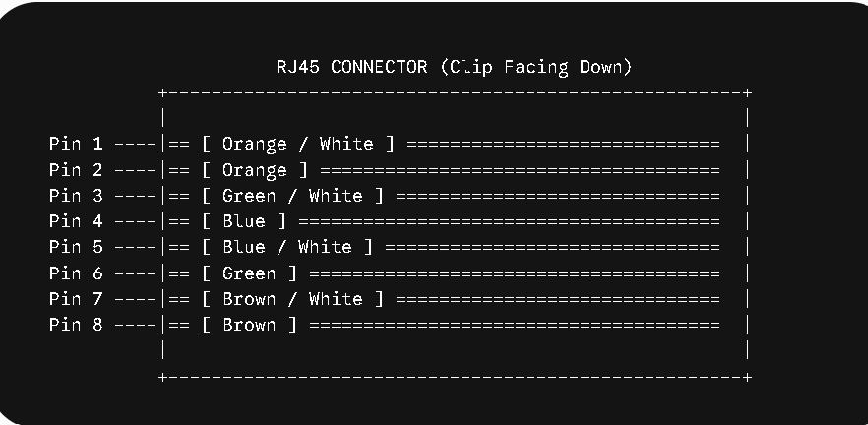
Pin-to-Color Mapping (T568B Both Ends)
- Pin 1: Orange / White
- Pin 2: Orange
- Pin 3: Green / White
- Pin 4: Blue
- Pin 5: Blue / White
- Pin 6: Green
- Pin 7: Brown / White
- Pin 8: Brown

TASK 3:
. Strip the Outer Jacket: Insert the end of the Cat6 cable into the stripping blade of your cable stripper/crimper, rotate it ${360}^{∘}$, and gently remove about 1.5 inches ($3.8\text{ cm}$) of the outer PVC jacket.
. Remove Spline & Untwist Pairs: Cut away the central plastic separator (spline) and rip cord using wire cutters. Untwist all four pairs of wires completely and straighten them with your fingers.
. Arrange Wires in Order (T568B): Line up the individual wires side-by-side according to the T568B color order: Orange-White, Orange, Green-White, Blue, Blue-White, Green, Brown-White, Brown.
. Trim to Length: Flatten the ordered wires tightly together and use the cutting blade on your crimper to trim them straight across, leaving about 0.5 inches ($1.3\text{ cm}$) of exposed wire.
. Insert into RJ45 Plug: Hold the RJ45 connector with the plastic locking tab facing down. Push the ordered wires firmly into the connector until all 8 conductors touch the front metallic contacts. Ensure the outer cable jacket extends slightly inside the connector body for strain relief.
. Crimp the Connector: Insert the loaded RJ45 plug into the matching socket of your RJ45 crimper tool and squeeze the handles together firmly until you hear/feel a solid click.
. Test the Connection: Use a cable tester to check all 8 pins for proper continuity on both ends before plugging it into active hardware.
TASK 4 :
1. Selected Hardware & Tools
Component | Selected Option | Alternative Considered
Cable Type | Cat6 / Cat6a Copper Ethernet Cable | Fiber Optic Cable
Termination Tool | RJ45 Crimper | Fiber Cleaver & Fusion Splicer
Switch | 16-Port Gigabit Unmanaged/Managed Switch | Multiple 4-Port Routers
2. Comprehensive Justification
A. Speed and Performance Requirements
- Gigabit Bandwidth: Modern multiplayer LAN gaming (like Valorant, CS:GO, Dota 2, or Call of Duty) requires ultra-low latency rather than massive bandwidth. A Cat6 Ethernet cable delivers up to 10 Gbps at distances up to 55 meters (and 1 Gbps up to 100 meters).
- Latency (Ping): On a localized LAN inside a single room, Cat6 copper Ethernet provides near-zero latency ($<1\text{ ms}$ delay to the switch). Fiber optic cables offer no tangible ping advantage over such short physical distances.
B. Distance & Physical Constraints
- Ethernet cables are rated for up to 100 meters (328 feet) per segment. In a 10-PC gaming café setup, the longest cable run from the central switch to any PC station will typically be under 15–20 meters.
- Flexibility & Durability: Cat6 cables are flexible, durable, and can easily bend around corners, run through cable raceways, or sit under desk setups without snapping. Fiber optic cables contain delicate glass strands that can fracture if bent sharply.
C. Budget & Cost-Efficiency
- Tooling Cost: An RJ45 crimper costs roughly $\$10-\$25$. In contrast, fiber optic tools (like a precision fiber cleaver and a fusion splicer or mechanical splicing kit) cost hundreds to thousands of dollars.
- Component Cost: RJ45 connectors and Cat6 bulk spools are significantly cheaper than Fiber SFP modules, optical connectors, and fiber patch cables.
- Maintenance & Repair: If a cable clip breaks or a wire is damaged by a chair wheel in the café, a technician can re-crimp a new RJ45 head in under 2 minutes using standard copper crimping tools.
3. Step-by-Step Network Topology
[ ISP Line (Fiber or Cable) ]
│
▼
[ ISP Modem / ONU ]
│
▼ (WAN Port)
[ MAIN ROUTER ]
(Handles NAT/DHCP/Firewall)
│
▼ (LAN Port)
[ 16-Port Gigabit Switch ]
│ │ │ │ │ │ │ │ │ │
▼ ▼ ▼ ▼ ▼ ▼ ▼ ▼ ▼ ▼
PC1 PC2 PC3 PC4 PC5 PC6 PC7 PC8 PC9 PC10
- Gateway Connection: The main internet line enters the Modem, which connects to the WAN port of the Router (handling local IP distribution via DHCP).
- Switch Interconnect: A single Cat6 Ethernet cable connects one of the Router's LAN ports to an uplink port on the 16-Port Gigabit Switch.
- PC Terminations: 10 individual Cat6 Ethernet cables run from the switch to each of the 10 gaming PCs, terminated on both ends with standard RJ45 plugs using the T568B wiring standard.

